1. 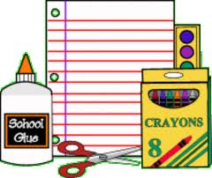Plastic shoebox to be used as cubby/ mailbox (NAME PLEASE!)
2. Art Smock/Paint shirt (NAME PLEASE!)
3. Complete change of clothes to leave in locker (shirt, pants, socks, undies). (NAME ON BAG) Water play, paint, exuberant washing, and occasional accidents & illness make this a necessity!
4. Pocket folder to organize papers to & from school (stays in backpack)
5. **Small** sippy cup or water bottle (NAME PLEASE!) [fat large bottles take too much room!]
6. A backpack or school bag large enough to carry library books & art projects (Name please)
7. A tub or refill pack of baby wipes
8. Crayola markers (broad tip/not fine) 8-10 count box.
9. Box of tissues (am class)/ Pkg of glue sticks (pm class)

